The 11th International Symposium on Plant-Soil Interactions at Low pH (11th PSILPH), which will be held during October 16-21, 2023 in Nanjing China.

- Welcome to use PayPal.Me to pay the registration fees of 11th PSILPH 2023. Here are the procedures.

- Link：PayPal.Me/PSILPH2023. Click here or paste on browser.

- Click SEND, you need to log in Paypal account or sign up.
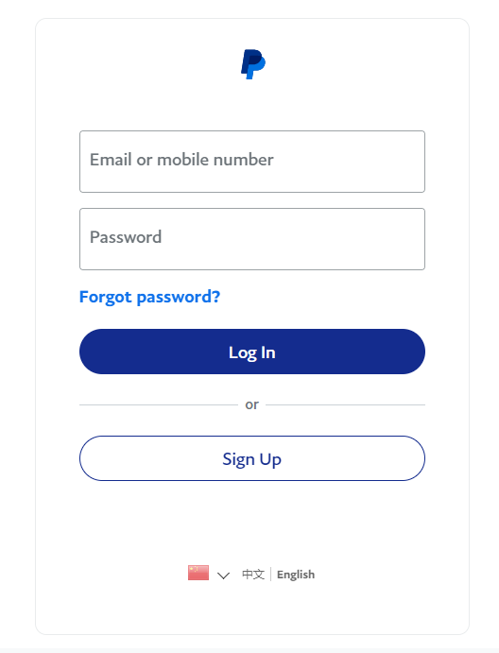

- Please enter the amount of registration fee according to the rates.
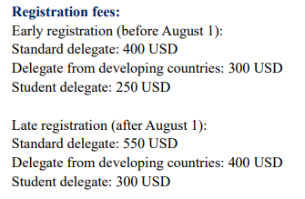

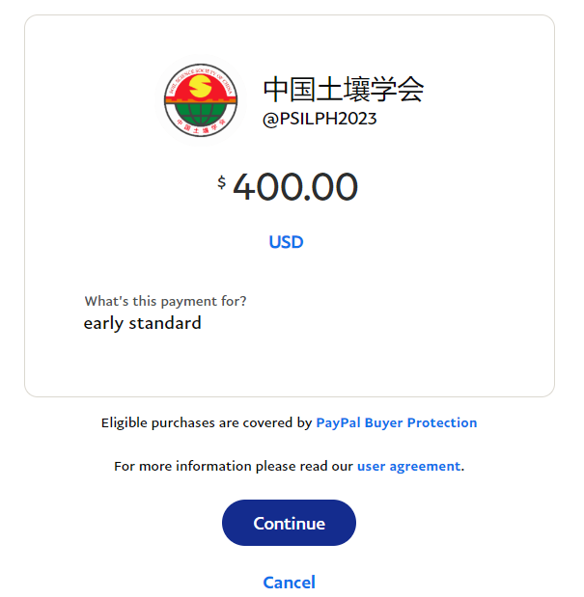

- Please select your shipping address and payment option. Then finish the payment.
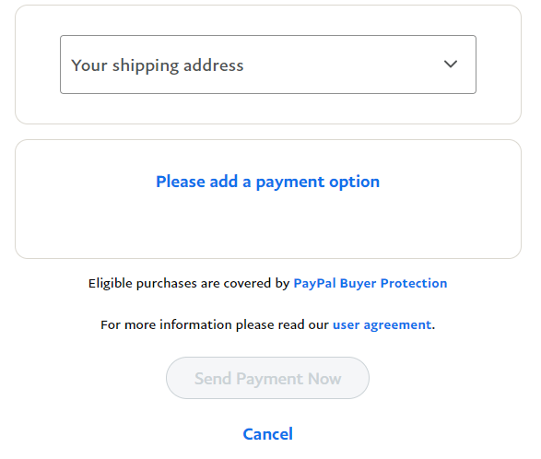
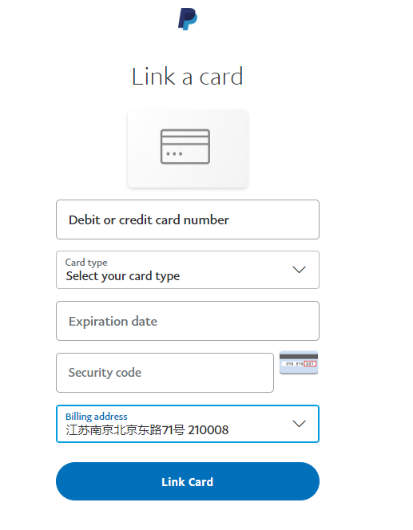
*Card type: Visa/MasterCard/American Express/discover/Union Pay/Diners Club
- You can also ask for an invoice to pay the registration fee, please let us know the email address to receive the invoice and choose payment option as your convenience.

